Home Work Music: Oracle SQL Class

Table of Contents

Table of Contents
Home Work Music: Oracle SQL Class 1
Table of Contents 1
1. Homework Music: Instructions 3
ORDER OF OPERATIONS 3
2. 5
3. Homework Music: Confirmation 6

Homework Music: Instructions
Create the tables for this homework in your student schema

ORDER OF OPERATIONS
When creating tables
    - Create the parent table first (if more than 1 then either one)
    - Create the primary key on the parent table(s)
    - Create the child table
    - Create the primary key on the child table
    - Create the foreign ley on the child that points to the primary key on the parent(s)

When adding data
- Add the parent records first (if more than 1 parent then either one)
- If more than one parent exists add the next parent record next
- Then add the child record using the primary key values from parent/parents

When deleting data
- Delete the child record first
- Then you can delete one or more parents if you need to in whichever order you like

Homework Music: ER Diagram 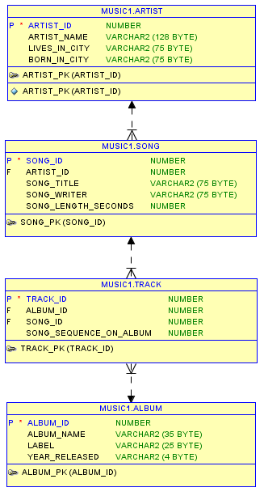
Artist is parent to Song
Song is child to Artist
Song is parent to Track
Album is parent to Track
Track is child to Song
Track is child to Album

one to many
one to many
one to many

Homework Music: Confirmation
Create the tables and constraints as discussed above. Insert the data for three of your own albums.
Copy and paste the SQL statements below into SQL developer. Modify them to run against your own tables if necessary.
Create a Microsoft Word document called HW_Music_Confirmation.doc.
Copy Query No. 1 into the Word document. Then run the first query in SQL Developer. It will produce a result set in the bottom right window. Use your mouse to slide over all of the cells in the SQL Developer output window to select the output, then press CTRL-C to copy the results set to the clipboard. Then move your mouse over the Microsoft Word window and click CTRL-V to paste the results set under Query No. 1 in the word document. (don’t worry if you do not paste the column headings or row numbers—just the data is fine).
Email me the HW_Music_Confirmation.doc before Wednesday's class. Email me if you have any questions.
-- ---------------------------------------------------
-- Homework Music: Confirmation
-- ---------------------------------------------------
-- 1. Question. List the artist’s names
select artist_name
from artist;
-- Copy and paste this SQL with the results from SQL Developer
-- into a Word doc
-- ---------------------------------------------------
-- 2.Question. List the song titles and artist's name for every
-- song you have and sort the list by song title
select artist_name, song_title
from artist ar, song s
where ar.artist_id = s.artist_id
order by song_title;
-- Copy and paste the SQL with SQL Developer results into the
-- same Word doc as No.1
-- ---------------------------------------------------
-- 3.Question. List the album name and song titles for each album
-- and sort by album_name
select album_name, song_title
from song s, track t, album al
where s.song_id = t.song_id
and t.album_id = al.album_id
order by album_name;
-- Copy and paste the SQL with SQL Developer results
-- into the same Word doc as No.1
-- ---------------------------------------------------
-- 4.Question. You are trying to decide if you want to
-- buy another album from an artist you already have
-- in your collection.
-- So list artist_name, album_name, song_title for every album
-- you have for that artist.
-- I will use Cher. Change Cher in the following query
-- to an artist in your database. Remember the artist name
-- must be the same case as your data in the table
select artist_name, album_name, song_title
from artist ar, song s, track t, album al
where ar.artist_id = s.artist_id
and s.song_id = t.song_id
and t.album_id = al.album_id
and artist_name = 'Cher';
-- Copy and paste the SQL with SQL Developer results into the Word doc
-- ---------------------------------------------------

